UNIT 1 — Web Framework & Node.js Basics
1 Mark Questions
- What is Full Stack Development? What is a Web Server? Explain its role in a full stack web application.
Full Stack Development is the development of both frontend (client-side) and backend (server-side) along with database management in a web application.
A web server is a system that receives HTTP requests from clients and sends responses.
Role in Full Stack Application:
- Handles incoming requests from frontend
- Sends requests to backend logic
- Returns processed data to the client

- Define the MERN stack. What role does each component play?

MERN stack is a popular, open-source JavaScript framework used for building dynamic, high-performance, and scalable full-stack web applications. It comprises of: MongoDB, Express.js, React and Node.js.
MongoDB (Database): A NoSQL, document-oriented database that stores data in flexible, JSON-like documents.
Express.js is a minimalist, open-source web application framework for Node.js Used for building server-side applications and APIs using JavaScript.
React (Frontend Library): A JavaScript library created by Facebook for building user interfaces. It enables developers to create interactive, dynamic, and component-based frontend UIs.
Node.js (Runtime Environment): A JavaScript runtime environment that allows developers to run JavaScript on the server side.

- Write primitive and non-primitive data types of JavaScript.
Primitive Data Types:
- Number
- String
- Boolean
- Null
- Undefined
- Symbol
Non-Primitive Data Types:
- Object
- Array
- Function

- What is an arrow function in JavaScript? Write an example.
An arrow function is a short syntax for writing functions in JavaScript (introduced in ES6).
It uses the => operator to define functions in a more concise way.
EXAMPLE:
const add = (a, b) => {
return a + b;
};

- What are callbacks in JavaScript? How do they help in asynchronous programming?
A callback is a function passed as an argument to another function, executed after a task is completed.
Role in Asynchronous Programming:
- Callbacks help in asynchronous programming i.e perform tasks without blocking execution
- Executes code after operations like API calls or file reading
Example:
function greet(name, callback) {
console.log("Hello " + name);
callback();
}

10-mark Questions
- Explain the web development framework. Describe the roles of User, Browser, Webserver, and Backend Services with a neat diagram.
Definition:
A web development framework is a structured platform used to build web applications efficiently by organizing components like client, server, and database.
Roles of Components:
1. User:
The person who interacts with the application through a browser. Sends requests and views responses.
2. Browser:
- Sends HTTP/HTTPS requests
- Renders HTML, CSS, JavaScript
- Displays output to the user
- Acts as the interface between user and server.
3. Web Server:
- Receives client requests
- Routes requests to backend
- Sends responses back
4. Backend Services:
- Processes business logic
- Validates data
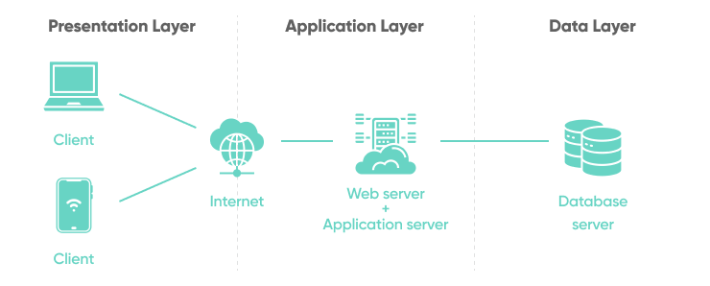
- Communicates with database

2.Explain the following JavaScript concepts with examples: var, let, const, functions, callbacks, template literals, and arrow functions.
1. var, let, const
- var: Function-scoped, can be re-declared and reassigned
- let: Block-scoped, cannot be re-declared but can be reassigned
- const: Block-scoped, value cannot change
var x = 10;
let y = 20;
const z = 30;

2. Functions
Reusable block of code.
function add(a, b) {
return a + b;
}

3. Callbacks
Function passed as argument.
function greet(name, callback) {
console.log(name);
callback();
}

4. Template Literals
Used for string formatting with backticks (`).
let name = "Ali";
console.log(`Hello ${name}`);

5. Arrow Functions
Short syntax for functions. Defines function in more precise way.
const add = (a, b) => a + b;

3.What is Node.js? List its features and advantages. Explain how to install Node.js, manage packages using npm, and run a simple Hello World program.
Definition:
Node.js is a server-side runtime environment that allows JavaScript to run outside the browser.

Features:
- Asynchronous & Non-Blocking I/O – handles multiple requests efficiently.
- Event-Driven Architecture – executes code based on events.
- Single-Threaded with Event Loop – handles one request at a time.
- High Performance – powered by V8 engine.
- Scalability – supports large-scale applications.
- Cross-Platform – runs on Windows, Linux, macOS.
- Rich Ecosystem – npm provides thousands of packages.
- Real-Time Capability – ideal for chat apps, live notifications.

Advantages:
- Fast execution
- Handles multiple requests
- Real-time applications
- Uses JavaScript for full stack
- Large community and ecosystem.
- Supports JSON for easy data exchange.

Steps to Install Node.js:
- Download from official website
- Run installer
- Follow setup instructions
- Verify installation:
node -v
npm -v

npm (Node Package Manager):
- Installs and manages packages
- Commands:
  - npm init → create project config file.
  - npm install express → install package locally.
  - npm install -g nodemon → install globally.

Hello World Program:
console.log("Hello Node.js");
Run using:
node app.js

4. Explain the Node.js Event Model and Event Queue. How does Node.js handle non-blocking I/O using callbacks? Illustrate with an example.
Event Model (Definition):
Node.js follows an event-driven architecture where execution is controlled by events such as user requests or file operations.

Key Components:
- Event: Action (e.g., request received)
- Event Emitter: Generates events
- Event Listener: Waits for events
- Event Handler: Executes when event occurs

Working of Event Model:
- Event occurs
- Event emitter triggers it
- Listener detects it
- Handler function executes

Example:
const EventEmitter = require("events");
const emitter = new EventEmitter();
emitter.on("greet", () => console.log("Hello User!"));
emitter.emit("greet");

Event Queue and Event Loop
- Event Queue: Stores completed async tasks
- Event Loop: continuously checks and Moves tasks to call stack when it is empty
Working:
- Code runs in call stack
- Async tasks go to background
- Completed tasks enter queue
- Event loop pushes them to stack

Non-Blocking I/O using Callbacks
Node.js does not wait for tasks to complete. It uses callbacks to handle operations asynchronously.
Example:
console.log("Start");
setTimeout(() => {
console.log("Async Task");
}, 0);
console.log("End");
Output:
Start
End
Async Task

Explanation:
- Async task is handled in background
- Callback executes after main code finishes

UNIT 2 — Node.js Modules & HTTP
1 Mark Questions
1. What is JSON? How is it used in Node.js?
JSON (JavaScript Object Notation) is a lightweight data format used to store and exchange data.
In Node.js, it is used to transfer data between client and server using methods like JSON.parse() and JSON.stringify().

2.What is the purpose of the Buffer module in Node.js?
The Buffer module is used to handle binary data (raw bytes) in memory.
It is mainly used in file handling, streams, and network operations.

3.What is the Stream module in Node.js? How does it differ from Buffer?
Streams are used to process data in chunks instead of loading entire data into memory.
Difference: Streams handle data continuously (chunk-wise), whereas Buffer stores fixed-size data temporarily.

4.What is the purpose of the dns module and crypto module in Node.js?
dns module: Used to convert domain names into IP addresses.
crypto module: Used for encryption, hashing, and secure data handling.

5.What is the difference between HTTP and HTTPS in Node.js?
HTTP: Transfers data in plain text (not secure).
HTTPS: Transfers data in encrypted form using SSL/TLS (secure).

10mark Questions
1.What is JSON? Explain how to read and write JSON data in Node.js using JSON.parse() and JSON.stringify() with examples. Also describe the Buffer module and its use.

JSON Definition:
JSON (JavaScript Object Notation) is a lightweight data-interchange format used to store and exchange data between client and server.
Use in Node.js:
- Used in APIs, configuration files, and data transfer
- Works easily with JavaScript objects

JSON Methods:
1. JSON.parse()
Converts JSON string → JavaScript object
let jsonData = '{"name":"Ali","age":21}';
let obj = JSON.parse(jsonData);
console.log(obj.name);

2. JSON.stringify()
Converts object → JSON string
let obj = {name:"Ali", age:21};
let str = JSON.stringify(obj);
console.log(str);

Buffer Module:
Definition:
Buffer is used to handle binary data (raw bytes) in memory.
Example:
let buf = Buffer.from("Hello");
console.log(buf);
console.log(buf.toString());
Uses:
- File handling
- Network communication
- Streaming

2.Explain how to create an HTTP server in Node.js. Describe how to handle GET requests, process URLs, Query Strings, and Form Parameters with code examples.

Creating HTTP Server: Node.js provides a built-in module called Node.js http to create servers.

const http = require("http");
const server = http.createServer((req, res) => {
res.write("Hello Server");
res.end();
});
server.listen(3000);

Handling GET Requests: You can check the request method using req.method.
if (req.method === "GET") {
res.write("GET Request");
}

URL & Query String: Use the built-in url module to parse request URLs.
const url = require("url");
const server = http.createServer((req, res) => {
let parsed = url.parse(req.url, true);
let name = parsed.query.name;
res.write("Hello " + name);
res.end();
});

Form Parameters (Basic):
- Data is sent using query string or POST
- Extracted from req object
Form parameters are the data sent from an HTML form to a server (like name, email, etc.).
They are usually sent in the request body (POST) or URL (GET) as key–value pairs (name=John).
In Node.js, you read them using req.body (Express) or by parsing the request data manually.
const http = require("http");

http.createServer((req, res) => {
if (req.method === "POST") {
let body = "";

req.on("data", chunk => body += chunk);

req.on("end", () => {
const params = new URLSearchParams(body);
const name = params.get("name");

res.end("Hello " + name);
});
}
}).listen(3000);

3.Explain File System operations in Node.js — Opening, Closing, Reading, and Writing files. Write programs using both synchronous and asynchronous methods using the fs module.
The fs module is used to read, write, open, and delete files.
Synchronous Example:
const fs = require("fs");
let data = fs.readFileSync("file.txt", "utf-8");
console.log(data);
fs.writeFileSync("file.txt", "Hello Node");

Asynchronous Example:
fs.readFile("file.txt", "utf-8", (err, data) => {
console.log(data);
});
fs.writeFile("file.txt", "Hello", (err) => {
console.log("Written");
});

Other Operations:
Open File
fs.open("file.txt", "r", (err, file) => {
console.log("Opened");
});
Close File
fs.close(fd, () => {});

4.Describe the os, util, dns, and crypto modules in Node.js. Give one use case for each and write a simple program using any two of these modules.
1. OS Module
- Provides system information
const os = require("os");
console.log(os.platform());
Use Case: System monitoring, operating system information

2. util Module
- Utility functions like debugging, formatting and handling async code.
const util = require("util");
console.log(util.format("Hello %s", "Ali"));
Use Case: Debugging, promisify – converts callbacks to promises

3. DNS Module
- Resolves domain names into IP addresses
const dns = require("dns");
dns.lookup("google.com", (err, addr) => {
console.log(addr);
});
Use Case: Network applications like finding ip address of website

4. Crypto Module
- Encryption, hashing & security related problems.
const crypto = require("crypto");
const hash = crypto.createHash("sha256")
.update("password")
.digest("hex");
console.log(hash);

Use Case: Password security

5.Describe the Stream module in Node.js. Compare Readable and Writable streams with suitable examples
Streams handle data in chunks instead of loading entire data into memory.

Types of Streams:
Readable Stream
const fs = require("fs");
let rs = fs.createReadStream("file.txt");
rs.on("data", (chunk) => {
console.log(chunk.toString());
});

Writable Stream
let ws = fs.createWriteStream("out.txt");
ws.write("Hello Node");
ws.end();

Comparison:
Feature | Readable Stream | Writable Stream
Purpose | Read data | Write data
Example | File reading | File writing
Method | .on("data") | .write()

pipe() Method: The pipe() method is used to connect a readable stream to a writable stream, so data flows automatically from source to destination.
rs.pipe(ws);

UNIT 3 — MongoDB
1 Mark Questions
1. What is NoSQL? How is it different from a relational database?
NoSQL is a database system that does not follow the relational model and is used to handle unstructured or large-scale data.
Difference: NoSQL has a flexible (schema-less) structure, while relational databases use fixed tables with schemas.

2. What is a MongoDB Database? How is it different from a Collection?
A MongoDB database is a container that holds multiple collections.
A collection is a group of documents inside a database.

3. What is a Collection in MongoDB? How is it similar to a table?
A collection is a group of documents stored in MongoDB.
It is similar to a table in relational databases, but it has a flexible schema.

4. What is a MongoDB Document? How is it structured using BSON format?
A document is a record in MongoDB stored as key-value pairs.
It is structured internally using BSON (Binary JSON), which supports multiple data types like string, number, array, and object.

5. What is the use of the findOne() method in MongoDB? Write its syntax.
The findOne() method is used to retrieve a single document from a collection.
SYNTAX:
db.collection.findOne({ query, projection })
query (optional)
👉 Specifies the condition to match documents
projection (optional)
👉 Specifies which fields to include or exclude

6. What is the role of the MongoDB Node.js Driver? Name any two of its methods.
The MongoDB Node.js Driver acts as a bridge between Node.js application and MongoDB database. Two methods: connect() and close()

10mark Questions
1. What is MongoDB? List its features and advantages over traditional databases. Explain the following data types with examples: String, Number, Boolean, Array, and ObjectId.
OR
2. What is MongoDB? Explain the need for NoSQL databases. List and describe any four MongoDB Data Types with examples.

Definition:
MongoDB is a NoSQL, document-oriented database that stores data in JSON-like (BSON) documents instead of tables.

Features:
- Document-oriented storage
- Schema-less (flexible schema)
- High performance
- Horizontal scalability
- Indexing support
- High availability (replication)
- Rich query language

Need/ Advantages over RDBMS:
- Flexible schema
- Faster performance (no joins)
- Handles unstructured data
- Scalable (horizontal scaling)
- Cost-effective

Data Types with Examples:
1. String: Used to store text values
{ "name": "John" }
2. Number: used to store numeric values
{ "age": 22 }
3. Boolean: used to store true or false values
{ "isStudent": true }
4. Array: Stores multiple values in a single field
{ "skills": ["Node.js", "MongoDB"] }
5. ObjectId: is a special data type in MongoDB used to uniquely identify each document.
{ "_id": ObjectId("507f1f77bcf86cd799439011") }

3. Explain the need for NoSQL databases. Describe MongoDB Data Types and how to plan a data model in MongoDB.
Explain the need for NoSQL databases. Describe MongoDB Data Types same as above question

Types of Data Models:
1. Embedded Model (Denormalization)
- Stores related data in the same document
- Improves read performance
Example:
{
"name": "John",
"orders": [
{ "product": "Laptop", "price": 50000 }
]
}
Advantages:
- Faster data retrieval
- No joins required
Disadvantages:
- Data duplication
- Large document size

2. Referenced Model (Normalization)
- Stores data in separate collections
- Uses references (IDs)
Example:
// Users
{ "_id": 1, "name": "John" }
// Orders
{ "userId": 1, "product": "Laptop" }
Advantages:
- Avoids duplication
- Better for large data
Disadvantages:
- Requires multiple queries
- Slower than embedded

Factors to Consider:
- Application requirements
- Read vs write frequency
- Data size (16MB document limit)
- Performance needs
- Scalability

4. How do you connect MongoDB to a Node.js application? Write a simple program to connect to MongoDB and display all documents from a collection using find().
OR
5. How do you connect MongoDB with Node.js? Write a simple Node.js program to connect to a MongoDB database and insert a document into a collection.
ans)
1. Definition
Connecting MongoDB to a Node.js application refers to the process of establishing a connection between
the application and the MongoDB database using the MongoDB driver, so that data can be accessed
and manipulated.

2. Why Connection is Required
. A Node.js application cannot directly communicate with MongoDB without a driver.
. The MongoDB driver acts as a bridge between the application and the database.
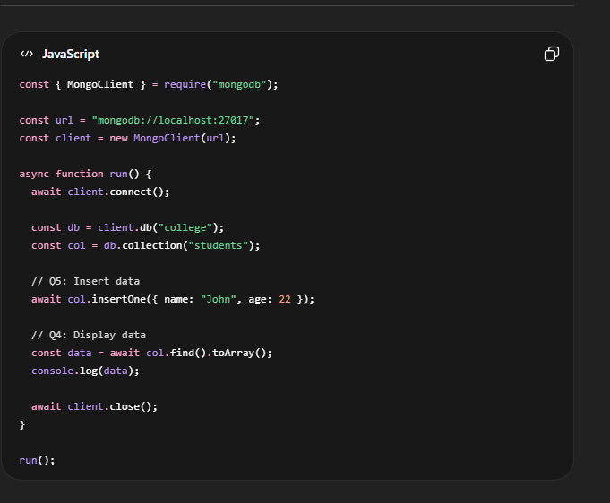
· It allows performing operations such as inserting, retrieving, updating, and deleting data.

6. Describe how to connect MongoDB with Node.js using the MongoDB Node.js Driver. Explain how to access and manipulate databases.
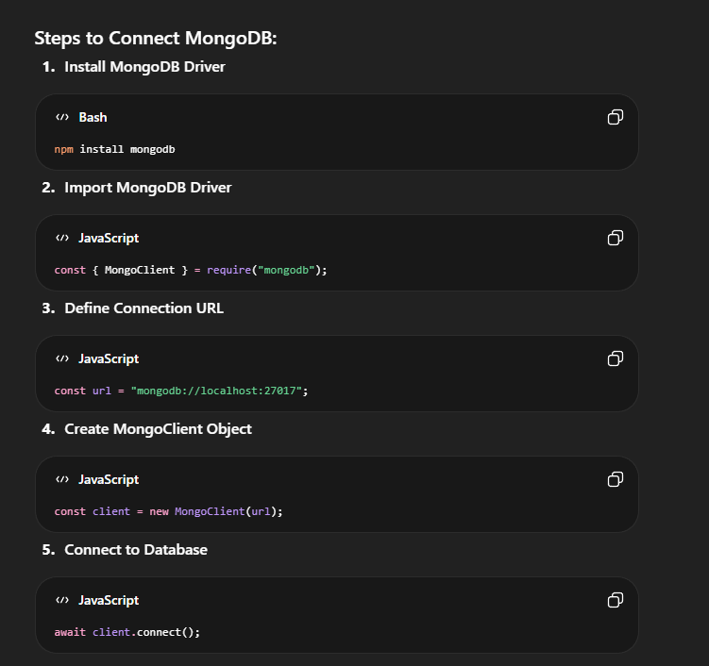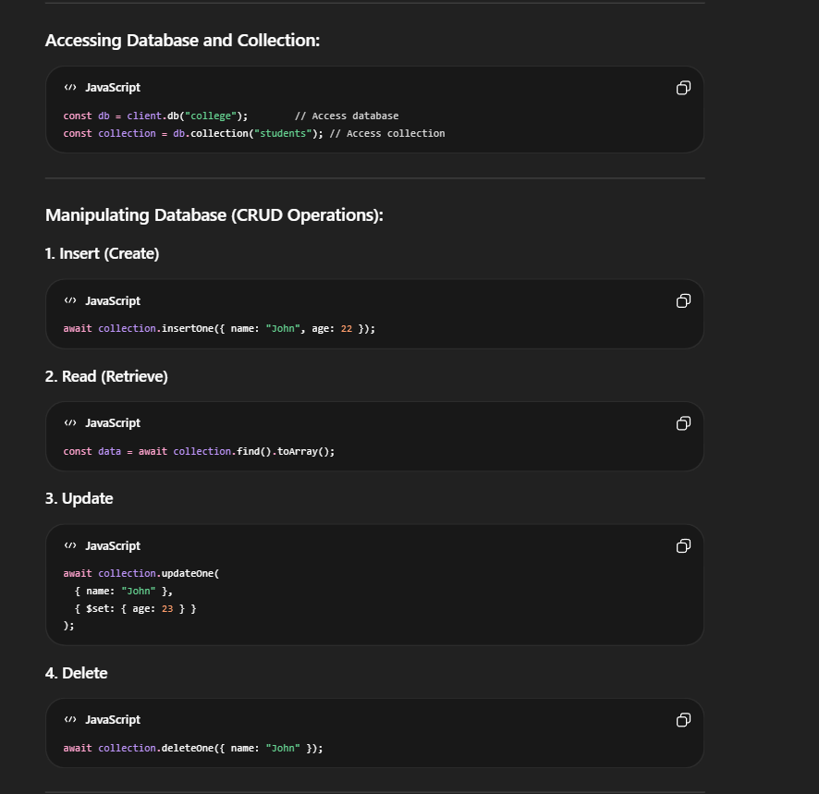

7. Explain how to create a database and collection in MongoDB. Show how to create a user and assign read/write roles using MongoDB shell commands.
OR
8. How do you create a user in MongoDB? Explain how to create a database, create a collection, and assign basic access permissions with commands.

In MongoDB, databases and collections are used to store data, and users are created to control access and permissions.
1. Creating a Database
MongoDB creates a database automatically when data is inserted.
Command:
use college
- Switches to college database
- If not exists, it will be created when data is added

2. Creating a Collection
Method 1: Implicit Creation
db.students.insertOne({ name: "John", age: 22 })
- Collection is created automatically
Method 2: Explicit Creation
db.createCollection("students")

3. Creating a User in MongoDB
Step 1: Switch to admin database
use admin
Step 2: Create User
db.createUser({
user: "testUser",
pwd: "12345",
roles: [{ role: "readWrite", db: "college" }]
})
read → Can only view data
readWrite → Can read and modify data

9. Explain how to administer user accounts and configure access control in MongoDB with relevant commands.
Administering user accounts in MongoDB means creating, managing, and controlling users and their permissions.
Access control ensures that only authorized users can access and perform operations on the database.

Key Concepts:
1. Authentication
Verifies user identity (username & password)
2. Authorization
Defines what actions a user can perform
3. Roles (RBAC)
MongoDB uses Role-Based Access Control
Common roles:
  - read → view data
  - readWrite → read & modify data
  - dbAdmin → manage database
  - root → full access

Steps to Configure Access Control:
Step 1: Start MongoDB Server
mongod

Step 2: Create Admin User
use admin
db.createUser({
user: "admin",
pwd: "admin123",
roles: [{ role: "root", db: "admin" }]
})

Step 3: Enable Authentication
mongod --auth

Step 4: Login with Credentials
mongosh -u admin -p admin123 --authenticationDatabase admin

Step 5: Create Application User
use college
db.createUser({
user: "student",
pwd: "123",
roles: [{ role: "read", db: "college" }]
})

User Management Commands:
View users:
- show users
Update password:
- db.updateUser("student", { pwd: "newpass" })
Delete user:
- db.dropUser("student")

Example (Real-Time):
- Admin → full access
- Teacher → read/write
- Student → read only

Advantages:
- Ensures data security
- Controls user access
- Prevents unauthorized usage

10. Write and explain the following MongoDB operations with syntax and a simple example: insertOne(), find(), updateOne(), deleteOne().
OR
11. Explain the following MongoDB operations with syntax and example: insertOne(), find(), updateOne(), deleteOne().
OR
12. Describe CRUD operations (Create, Read, Update, Delete) on MongoDB Collections with code examples.

1. insertOne() (Create Operation)
Definition:
Used to insert a single document into a collection.
Syntax:
db.collection.insertOne(document)
Example:
db.students.insertOne({ name: "John", age: 22 })

2. find() (Read Operation)
Definition:
Used to retrieve documents from a collection.
Syntax:
db.collection.find(query)
Example:
db.students.find()

3. updateOne() (Update Operation)
Definition:
Used to update a single document in a collection.
Syntax:
db.collection.updateOne(filter, update)
Example:
db.students.updateOne(
{ name: "John" },
{ $set: { age: 23 } }
)

4. deleteOne() (Delete Operation)
Definition:
Used to delete a single document from a collection.
Syntax:
db.collection.deleteOne(filter)
Example:
db.students.deleteOne({ name: "John" })

UNIT 4 — Express.js & Angular
1 Mark Questions
1. What is Express.js? State its primary purpose in web development.
- Express.js is a fast, minimal, and flexible web application framework for Node.js.
- Its primary purpose is to simplify building web servers, APIs, and backend applications.

2. What is a route in Express.js? Give an example of a GET route.
A route defines how the server responds to a client request (URL + HTTP method).
Example:
app.get("/", (req, res) => {
res.send("Home Page");
});

3. What are middleware functions in Express.js? Why are they used?
Middleware functions run between the request and response cycle. They are used for logging, authentication, and data parsing

4. What is an Angular Component? Name its main parts.
An Angular Component is the basic building block of UI in Angular.
Main parts: TypeScript (logic), HTML template (view), CSS (style).

5. What are Angular Directives? Differentiate between built-in and custom directives.
They act as special instructions for the Angular compiler to modify the appearance, behaviour, or structure of the Document Object Model (DOM).
- Built-in directives: Provided by Angular (e.g., *ngIf, *ngFor, ngStyle).
- Custom directives: User-defined to add new DOM behavior (e.g., appHighlight).

6. What is Data Binding in Angular? Name its types.
Data binding in Angular is a core mechanism that synchronizes data between an application's logic (the Component) and its user interface (the Template)
- Interpolation ({{ }})
- Property Binding ([property])
- Event Binding ((event))
- Two-Way Binding ([(ngModel)])

10 Mark Questions
1. What is Express.js? Write a simple Express.js server that handles a GET request on '/' and a POST request on '/submit'. Explain the req and res objects used.
OR
2. What is Express.js? Write a simple Express.js application that handles GET and POST routes. Explain the use of req and res objects.
Express.js is a fast, minimal, and flexible web application framework for Node.js used to build web servers, APIs, and backend applications.
Why Express.js
- Reduces boilerplate code of Node.js
- Provides routing and middleware
- Simplifies request-response handling
Simple Express Server:
const express = require('express');
const app = express();
// Middleware to parse JSON
app.use(express.json());
// GET request
app.get('/', (req, res) => {
res.send("Welcome to Home Page");
});
// POST request
app.post('/submit', (req, res) => {
const data = req.body;
res.send("Received Data: " + JSON.stringify(data));
});
app.listen(3000, () => {
console.log("Server running on port 3000");
});

req (Request Object)
- Represents client request
- Contains:
  - req.params → URL parameters
  - req.query → query string
  - req.body → POST data
res (Response Object)
- Sends response to client
- Methods:
  - res.send() → text/HTML
  - res.json() → JSON data
  - res.status() → HTTP status

3. Explain how to configure routes in Express.js. Describe the use of Request and Response objects with examples.
Ans) Definition
Routing is defining how the server responds to client requests (URL + HTTP method).
Syntax:
app.METHOD(PATH, HANDLER)
Example:
app.get('/home', (req, res) => {
res.send("Home Page");
});

app.post('/login', (req, res) => {
res.send("Login Successful");
});

Types of Routing
- GET → retrieve data
- POST → send data
- PUT → update data
- DELETE → delete data
Route Parameters
app.get('/user/:id', (req, res) => {
res.send("User ID: " + req.params.id);
});

Request & Response Usage
app.post('/data/:id', (req, res) => {
res.send("ID: " + req.params.id + ", Name: " + req.body.name);
});

4. What is Angular? Create a simple Angular application with one component. Explain the role of the component class, template, and selector.
OR
5. What is Angular? Create a simple Angular application and explain the role of Components, Templates, and Expressions in it.
OR
6. What is Angular? Explain Angular Components and Expressions with a simple Angular application example.

Definition
Angular is a TypeScript-based open-source, front-end framework managed by google used to build dynamic, scalable single-page applications (SPAs).
Simple Angular Example
Component:

import { Component } from '@angular/core';
@Component({
selector: 'app-root',
template: '<h1>{{ message }}</h1>'
})
export class AppComponent {
message = "Hello Angular";
}

Roles
1. Component
- Controls part of UI
- Contains logic (TypeScript)
- Manages data and functions
2. Template
- HTML view
- Displays data to the user
- Uses Angular syntax like {{ }} for dynamic data display
3. Selector
- Custom HTML tag (<app-root>)
- It connects the component with HTML
4. Expressions
- Angular Expressions are JavaScript-like expressions written inside {{ }} to display dynamic data in templates.
- Example:
<p>{{ 10 + 5 }}</p>

7. Explain the following Angular directives with a simple example for each: ngIf, ngFor, and ngModel.
OR
8. Explain the following Angular built-in directives with syntax and example: ngIf, ngFor, ngModel.
Built-in directives in Angular are predefined instructions that modify the structure or behavior of DOM elements. They help create dynamic and interactive web applications.

1. ngIf (Conditional Display): ngIf is a structural directive used to display or remove an HTML element based on a condition.
<div *ngIf="isLoggedIn">
Welcome User
</div>

2. ngFor (Loop): ngFor is a structural directive used to repeat HTML elements for each item in a collection or array.
<ul>
<li *ngFor="let item of items">
{{ item }}
</li>
</ul>

3. ngModel (Two-way Binding): ngModel is an attribute directive used for two-way data binding between component data and form elements.
<input [(ngModel)]="name">
<p>{{ name }}</p>

9. Explain Data Binding in Angular. Describe Built-in Directives (ngIf, ngFor, ngModel) with examples.
Definition:
Data Binding is the process of connecting component logic (TypeScript) with the view (HTML template) so data flows automatically.
Types:
- Interpolation: {{ name }} → displays component data in view.
- Ex: <h1>{{ name }}</h1>

- Property Binding: [property]="value" → binds data to element property.
- Ex: <img [src]="imageUrl">

- Event Binding: (event)="function()" → handles user actions.
- Ex: <button (click)="showMessage()">Click</button>

- Two-Way Binding: [(ngModel)]="data" → syncs component ↔ view.
- Ex: <input [(ngModel)]="name">

Built-in Directives in Angular
- Definition: Predefined instructions that modify DOM structure or behavior.
- Key Directives:
  - ngIf (Structural Directive): Displays element conditionally.
Ex: <div *ngIf="isLoggedIn">Welcome User</div>
2. ngFor (Structural Directive): Loops through items.
Ex: <ul>
<li *ngFor="let item of items">{{ item }}</li>
</ul>
3. ngModel (Attribute Directive): Enables two-way data binding.
Ex: <input [(ngModel)]="username">
<p>{{ username }}</p>

10. What is an Angular Service? Create a simple service that stores and returns a list of student names. Show how to inject and use it in a component.
OR
11. What is an Angular Service? Write a simple example to create and use a service in an Angular component.
Definition:
Angular Service is a reusable class that contains business logic, data handling, or shared functionality. It is used across multiple components via Dependency Injection (DI). Services help separate UI logic (components) from business logic, improving reusability and maintainability.
Steps to Create and Use a Service:
- Generate Service:
Ex: ng generate service student
This creates student.service.ts.

2. Service Code (student.service.ts):
Ex: import { Injectable } from '@angular/core';

@Injectable({
providedIn: 'root'
})
export class StudentService {
getStudents() {
return ["John", "Mike", "Ali"];
}
}
@Injectable() → Marks class as a service.
providedIn: 'root' → Makes it available globally.

3. Inject Service in Component (app.component.ts):
Ex: import { Component } from '@angular/core';
import { StudentService } from './student.service';

@Component({
selector: 'app-root',
templateUrl: './app.component.html'
})
export class AppComponent {
students: string[] = [];

constructor(private studentService: StudentService) {
this.students = this.studentService.getStudents();
}
}
4. Template (app.component.html):
Ex: <ul>
<li *ngFor="let s of students">{{ s }}</li>
</ul>

Role of Dependency Injection (DI):
- Angular automatically provides the service instance to the component.
- No need to manually create objects.
- Promotes loose coupling and cleaner code.
Advantages of Angular Services:
- Code reusability.
- Separation of concerns (UI vs logic).
- Easy data sharing between components.
Centralized business logic

12. Describe how to create Custom Directives in Angular. Explain how Angular Services are implemented in web applications.
Custom Directives in Angular are user-defined directives used to create custom DOM behavior and reusable functionality beyond Angular’s built-in directives.

Need for Custom Directives
- Extend HTML functionality
- Reuse common behavior
- Reduce repeated code
- Improve UI interaction

Types of Custom Directives
- Attribute Directives
  - Modify appearance or behavior of elements
- Structural Directives
  - Modify DOM structure

Steps to Create a Custom Directive:
  - Generate directive:
ng generate directive highlight
  - Code (highlight.directive.ts):
import { Directive, ElementRef } from '@angular/core'
@Directive({
selector: '[appHighlight]'
})
export class HighlightDirective {
constructor(el: ElementRef) {
el.nativeElement.style.backgroundColor = 'yellow';
}
}

  - Usage in template:
<p appHighlight>Highlighted Text</p>

Explanation: The directive changes the background color of the <p> element to yellow.

Angular Services in Web Applications
- Definition: Services are reusable classes that contain business logic or data. They are injected into components using Dependency Injection (DI).
- Purpose:
  - Share data across components.
  - Handle API calls, authentication, and reusable logic.
  - Promote separation of concerns (UI vs logic).

- Example Service (student.service.ts):
import { Injectable } from '@angular/core';

@Injectable({
providedIn: 'root'
})
export class StudentService {
getStudents() {
return ["John", "Mike", "Ali"];
}
}

- Injecting Service in Component (app.component.ts):
import { Component } from '@angular/core';
import { StudentService } from './student.service';

@Component({
selector: 'app-root',
templateUrl: './app.component.html'
})
export class AppComponent {
students: string[] = [];

constructor(private studentService: StudentService) {
this.students = this.studentService.getStudents();
}
}

- Template (app.component.html):
<ul>
<li *ngFor="let s of students">{{ s }}</li>
</ul>

UNIT 5 — React
1 Mark Questions
1. What is the Virtual DOM in React? Why is it used?
Virtual DOM is a lightweight copy of the real DOM stored in memory.
It is used to improve performance by updating only the changed parts instead of re-rendering the entire page.

2. What are React Components? Differentiate between functional and class components.
React components are reusable building blocks of UI that define how a part of the screen looks and behaves.
Difference:
- Functional → Simple functions, use Hooks
- Class → ES6 classes, use lifecycle methods

3. What is a prop in React? How is it different from state?
Props stands for properties -it used to pass data from parent to child components.
State is internal data of a component that can change.
4. What is the use of useState() hook in React? Write a simple example.
useState() is a REACT hook used to create and manage state in functional components.
Example:
const [count, setCount] = useState(0);

5. What are React Lifecycle Methods? Name the phases of a React component lifecycle.
Lifecycle methods are functions executed at different stages of a component.
Phases:
- Mounting
- Updating
- Unmounting

6. What is React Router? Why is routing important in single page applications?
React Router is used for navigation between pages in React applications.
It is important because it enables single-page applications without page reload, improving performance.

10 Mark Questions
1. Explain the need for React. Describe the Virtual DOM and how it improves rendering performance.
Earlier web development using HTML, CSS, and JavaScript (or jQuery) became difficult for large applications due to performance issues and complex UI management.

Need for React
In traditional web development, building large applications was difficult due to several problems:
- Manual DOM manipulation made code complex and error-prone
- Poor performance because the entire DOM was updated even for small changes
- Code reusability issues led to repeated code and difficult maintenance
- State management problems caused data inconsistency
- Applications were not scalable

How React Solves These Problems
React provides modern solutions:
- Virtual DOM → updates only changed parts, improving performance
- Component-based architecture → reusable UI components
- Declarative approach → easier and cleaner code
- One-way data binding → predictable data flow
- Efficient state management → automatic UI updates

Advantages of React:
- Fast performance
- Reusable components
- Easy to maintain
- Scalable applications

Virtual DOM in React
Definition:
Virtual DOM is a lightweight copy of the real DOM stored in memory, used by React to optimize updates.

Working of Virtual DOM:
Step 1: Initial Rendering
- React creates Virtual DOM and renders it
Step 2: State Change
- New Virtual DOM is created
Step 3: Diffing
- Compares old and new Virtual DOM
Step 4: Reconciliation
- Finds differences
Step 5: Update Real DOM
- Only changed parts are updated

Flow Diagram:
JSX → Virtual DOM → Diffing → Reconciliation → Real DOM

How Virtual DOM Improves Performance:
- Updates only changed elements
- Reduces direct DOM manipulation
- Faster rendering
- Improves user experience
- Efficient for large applications

2. Explain the difference between functional and class components in React. Write a simple example of each that displays a Welcome message.
Functional vs Class Components in React
Definition:
- Functional Components:
Simple JavaScript functions that return JSX (UI).
- Class Components:
ES6 classes that extend React.Component and use a render() method to return JSX.

Differences Between Functional and Class Components
Feature | Functional Component | Class Component
Syntax | Simple function | ES6 class
State | Uses Hooks (useState) | Uses this.state
Lifecycle | Uses Hooks (useEffect) | Uses lifecycle methods
Complexity | Simple | More complex
Usage | Modern React | Older approach

Example: Functional Component
function Welcome() {
return <h1>Welcome Student</h1>;
}
export default Welcome;

Example: Class Component
import React, { Component } from "react";
class Welcome extends Component {
render() {
return <h1>Welcome Student</h1>;
}
}
export default Welcome;

3. What is state in React? Write a simple counter application using the useState() hook that increments and decrements a count value.
State in React is a built-in object used to store and manage dynamic data inside a component.
When state changes, React automatically updates the UI (re-rendering).

Key Features of State:
- Mutable (can change)
- Managed within the component
- Triggers re-render when updated
- Used for dynamic data (like counters, inputs)

useState() Hook:
useState() is used in functional components to create and manage state.
Syntax:
const [state, setState] = useState(initialValue);

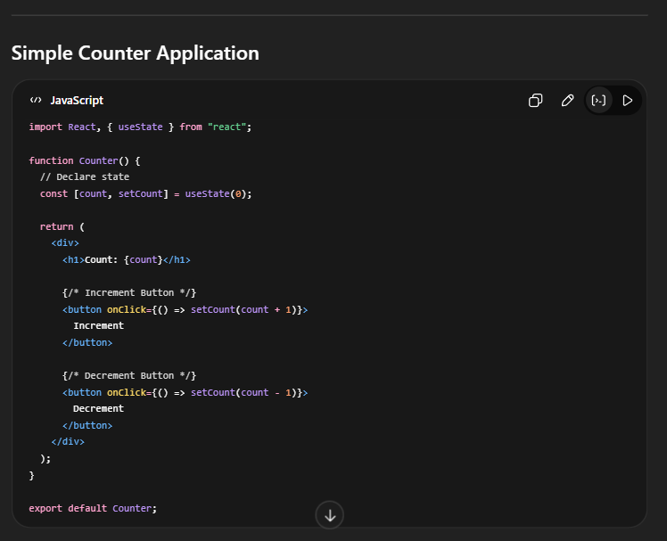

4. What are props in React? Write an example where a parent component passes name and age as props to a child component that displays them. Explain Data Flow in React.
Props (properties) are used to pass data from a parent component to a child component in React.
They are read-only (immutable) and cannot be modified by the child.
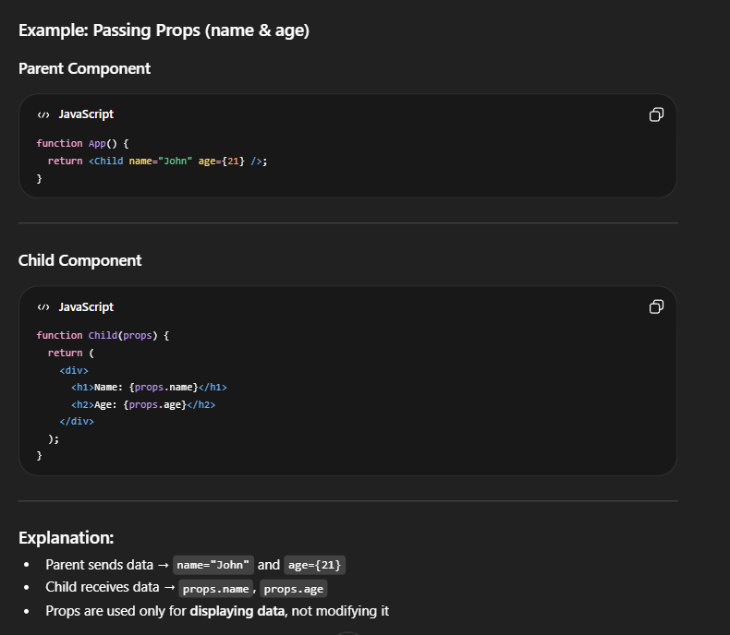
Data Flow in React
Definition:
Data flow in React refers to how data is passed and managed between components using props and state.

One-Way Data Flow (Unidirectional):
- Data flows in one direction only
👉 Parent → Child → UI

Example Flow:
Parent Component → Child Component → Display Output

Advantages of One-Way Data Flow:
- Predictable behavior
- Easy debugging
- Avoids data conflicts
- Better data management

5. Explain the React Component Lifecycle. Describe the Mounting, Updating, and Unmounting phases with the methods involved in each phase.
OR
6. Explain the React Component Lifecycle Methods in detail with a diagram. When and why is each method used?
Definition:
The React Component Lifecycle refers to the different stages a component goes through from creation to removal in the DOM.

Introduction:
Each component has a lifecycle similar to a human:
- Born → Mounted
- Lives → Updates
- Dies → Unmounted
These stages help developers control component behavior and perform operations like data fetching and cleanup.

Phases of Lifecycle
1. Mounting Phase (Creation)
Definition:
Occurs when a component is created and inserted into the DOM.
Methods:
- constructor()
Initializes state
- render()
Returns JSX (UI)
- componentDidMount()
Called after component is added to DOM
Use:
- API calls
- Data fetching

2. Updating Phase
Definition:
Occurs when state or props change.
Methods:
- shouldComponentUpdate()
Controls re-rendering
- render()
Updates UI
- componentDidUpdate()
Runs after update
Use:
- Perform actions after update
- Handle side effects

3. Unmounting Phase (Removal)
Definition:
Occurs when a component is removed from the DOM.
Method:
- componentWillUnmount()
Called before component is destroyed
Use:
- Cleanup tasks
- Stop timers or API calls

Lifecycle Diagram (Write in Exam)
Mounting → Updating → Unmounting

7. What are controlled components in React? Write a simple React form with name and email fields that uses state to capture and display input values.
Controlled Components in React
Definition:
Controlled components are form elements whose values are controlled by React state.
React becomes the single source of truth for form data.

Introduction:
In React, form inputs like text fields are handled using state instead of directly accessing the DOM.
This allows better control, validation, and real-time updates.

Key Features:
- Input values are stored in state
- Uses useState() hook
- onChange updates state
- Ensures synchronization between UI and data
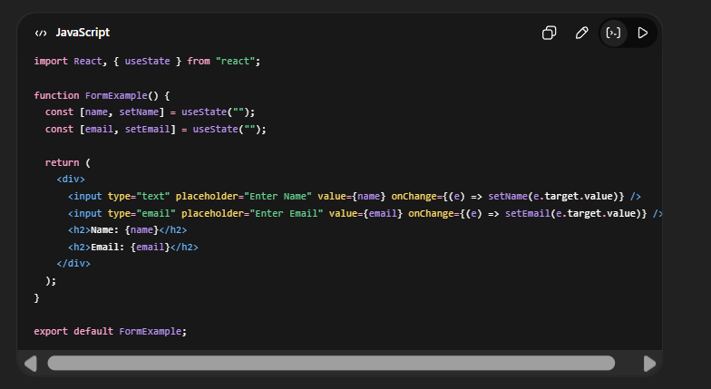
8. Describe how to work with Forms in React. Explain Routing in React using React Router with an example.
Working with Forms in React
Definition:
Forms in React are used to collect user input and are handled using state (controlled components).

Controlled Components:
- Input values are controlled by React state
- React is the single source of truth

Example (Form with Input):
import React, { useState } from "react";
function Form() {
const [name, setName] = useState("");
return (
<div>
<input value={name} onChange={(e) => setName(e.target.value)} />
<h2>{name}</h2>
</div>
);
}

Explanation:
- useState() stores input value
- onChange updates state
- UI updates automatically

Advantages:
- Full control over input
- Easy validation
- Real-time updates

Routing in React (React Router)
Definition:
Routing in React is the process of navigating between different pages (components) without reloading the page.

Why Routing is Important:
- Enables Single Page Applications (SPA)
- Faster navigation
- Better user experience
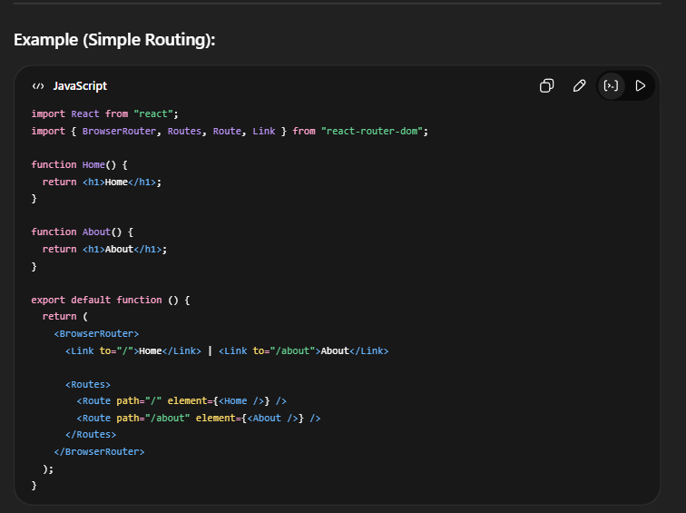
9. What is React Router? Write a simple React application with two pages — Home and About — using BrowserRouter, Route, and Link components.
OR
10. What is React Router? Write a simple React application with three pages — Home, About, and Contact — using BrowserRouter, Route, and Link.
React Router is a library used for navigation between different pages (components) in a React application without reloading the page.

Need for React Router:
- Enables Single Page Applications (SPA)
- Allows navigation without page refresh
- Improves performance and user experience

Key Components:
- BrowserRouter → Wraps the entire application
- Route → Defines path and component
- Link → Used for navigation

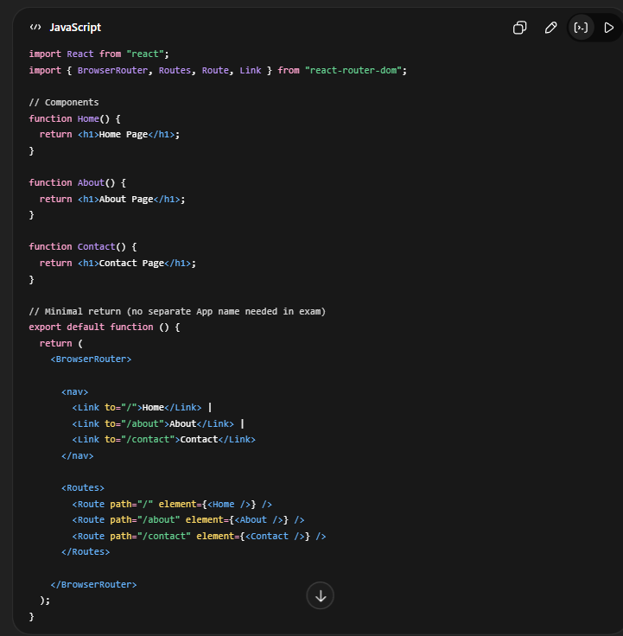

11. Explain how to use Axios in React to fetch data from an API and display it in a component.
Axios is a third-party library used to make
HTTP requests (GET, POST, etc.) in React applications.

Need for Axios:
- React does not have built-in HTTP request support
- Axios helps to fetch data from APIs easily
- Used to build dynamic applications

Steps to Use Axios in React:
1. Install Axios
npm install axios

2. Import Axios
import axios from "axios";

3. Use useEffect() to Fetch Data
- Data is fetched when component loads

• axios.get() → fetch data from API
• useEffect() → runs when component loads
• useState() → stores data
• map() → displays data

